Plugin Development Guide

Introduction
Savant is unique in the Genome Browser arena in that it was designed to be extensible through a rich plugin framework, which allows developers to provide functionality in addition to what is provided with the standard distribution.

Tutorial: Developing a Savant Plugin
In this tutorial, we describe the steps used to create the SavantStats plugin using the demo project included in the Savant SDK as a template.

The SavantStats Plugin:
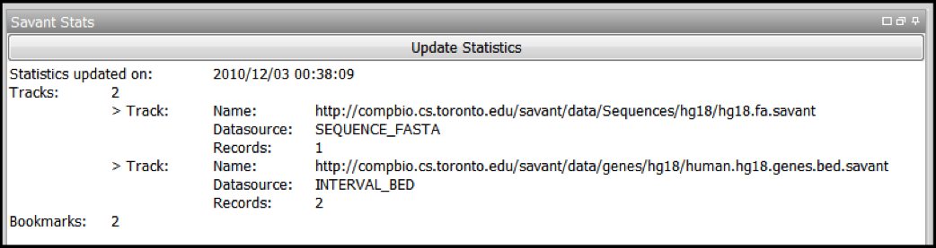
The SavantStats plugin was designed to demonstrate just some aspects of the API: in particular, accessing basic information about tracks and bookmarks. It does not cover much of what is offered through the API (for example, creating custom data-sources or visualizations). For more comprehensive coverage of the API, see the documentation contained within the SDK. Most importantly, this tutorial was designed to help you create a foundation for your own plugin project.

Prerequisites:
- JDK
- NetBeans
Note: for this tutorial, it is recommended to download the NetBeans + JDK Bundle
- Savant SDK

A. Set up the NetBeans Project

1. Set up NetBeans and the JDK
Download NetBeans and the JDK and install them. The links for these are listed above. For simplicity it is recommended to download the bundle, but you can certainly download and install them independently if you wish.

2. Set up the Savant SDK
Download the Savant SDK, listed above, and unzip it. The SDK contains the following components:
- api – documentation of the Savant code
- dev - development materials
- development manual
For this tutorial, we will refer to the dev folder in the SDK as dev/.

3. Open the Demo Project
Open NetBeans. Open the project in dev/savant.demo.

The "Project" and "Files" views should look something like this:
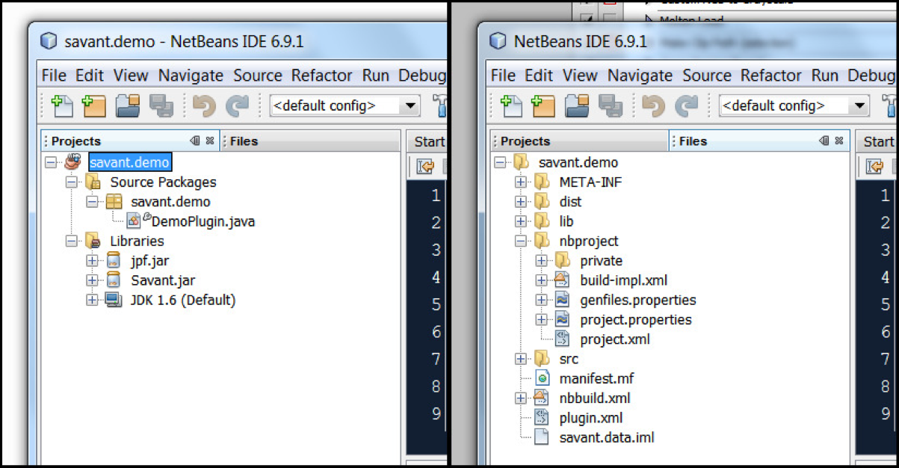

Description of Important Project Files:
- Project View
  - Source Packages: contains implementation of this plugin
    - Main package (savant.demo): contains the main class of the plugin
    - Main class (DemoPlugin.java): the class which implements the Savant Plugin interface
  - Libraries: contains links to external code packages
    - Savant.jar: Savant API, required for accessing Savant functions
- Files View
  - lib/: contains additional libraries used by this plugin
  - nbproject/project.properties : contains NetBeans project properties
  - nbbuild.xml: contains Ant instructions for building the project
  - plugin.xml: contains information about the plugin and how to run it

B. Editing the Demo Project to Your Own Plugin
You will need to know the following properties of your plugin:
- NAME: the name of the plugin.
- VERSION: the version of the plugin. In Savant we use the following scheme for version numbers [major version] . [minor version] . [bug fix / build number].
- PACKAGE: the main package of the plugin (which contains the main class).
- CLASS: the main class of the plugin.
In this example, NAME="Savant Stats", VERSION="1.0.0", PACKAGE="savant.stats", and CLASS="StatsPlugin".

1. Copy the Demo Project
Right-click the savant.demo project icon (looks like a coffee cup) and choose "Copy...". The copy dialog will be presented. In the Poject Name field, enter PACKAGE. Click the "Copy" button.
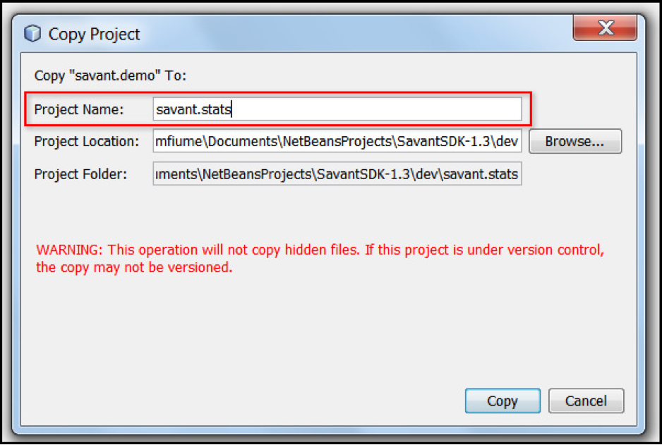
This will create a copy of the demo project which we will now edit to create a new plugin.

2. Rename the main package
Right-click the savant.demo package icon (looks like a cardboard box) and choose "Refactor > Rename...". In the New Name field, enter PACKAGE. Click the "Refactor" button.
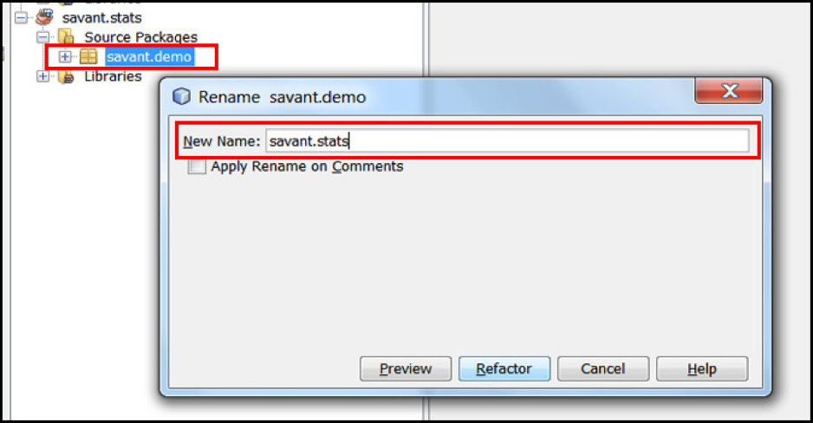

3. Rename the main class
Right-click the DemoPlugin.java icon and choose "Refactor > Rename...". In the New Name field, enter CLASS. Click the "Refactor" button.

4. Change the plugin name
Double-click the CLASS.java file (formerly DemoPlugin.java) to open it in the Editor. Change the getTitle() function to return "NAME".
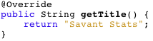

5. Edit the plugin properties
Switch to the "Files" view (the tab beside the "Projects" tab). Expand the new project. Double-click the plugin.xml file to open it in the editor. There are 5 places that need to be edited in this file, denoted in red boxes in the following figure:
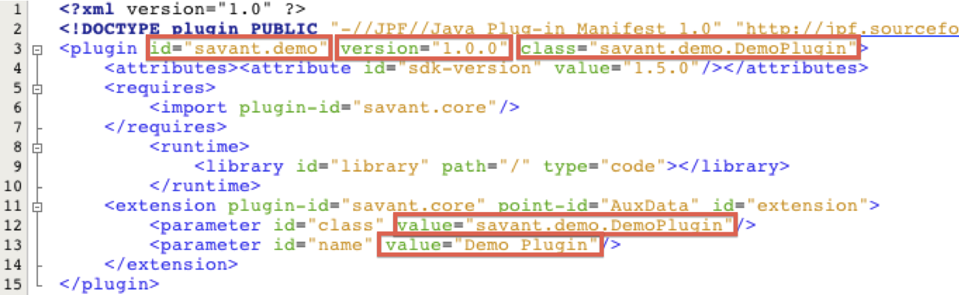
Here is how the file will be changed in the SavantStats example:
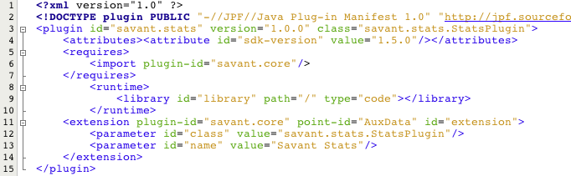

6. Change the project name
Open the nbbuild.xml file in the editor (it's in the same directory as plugin.xml). Change the name attribute of the project to PACKAGE.
At this point, we have created an independent plugin project which can be built and loaded into Savant. It is a good idea to try to do so now. See the section on "Building Plugins" section below.

C. Code Away!
You now have an independent plugin project as a foundation for your own plugin. You have two main tasks, outlined below. If you are following the SavantStats tutorial, you should download the complete SavantStats NetBeans Project to a separate location and copy the Java files in the dev/src directory of that package to the dev/src directory of your NetBeans project (overwriting StatsPlugin.java).
In general, the remaining tasks are:

1. Implementing the init() function
The init() function is called immediately when the plugin is loaded as Savant starts. The init function is responsible for initializing (among other things) the graphical components of the plugin (e.g. buttons, menus, etc.). The graphical "canvas" for plugins is a JPanel provided as an argument to the init() function. For help with JPanel and other Swing components visit here.

2. Implementing the rest of your plugin
Go nuts, you are free to do whatever you like in your plugin!

Suggested guidelines:
- thread long running tasks: Your plugin will run in the main Savant thread unless you tell it to do otherwise. This means that if your plugin does something which takes a long time (e.g. downloads files, performs a long computation, etc.) it will lock up the main thread until it has finished. Please perform such tasks in a separate thread.
- try to stick to what’s in the Savant API packages: The savant.api.adapter and savant.api.utils packages contains classes and methods which the Savant development team considers useful for developers to have. It is possible a developer requires some more functionality that can be found by getting access to a Savant instance. Please notify us of these situations so that we can consciously include such functionality in subsequent versions of the API, otherwise there is a risk that this functionality will be destroyed (since we're not expecting anyone to be using it directly) and your plugin will no longer work.

D. Submit your plugin
We strongly encourage you to submit all your developed Savant plugins to us, so that we can make them directly available to all Savant users. This is both a great way to promote your own work while encouraging more users and developers to join the Savant Community! You can submit your plugins to us through our Plugin Submission Form.

Plugin Development Tips and Tricks

Building and Testing Plugins
To build your plugin, Right-click the plugin project icon (the coffee cup) and choose "Build". NetBeans should output something like this:
What's important is that it builds successfully. Look in the dev/plugins directory. You should see a .jar file corresponding to your plugin (in the SavantStats example, it is savant.stats-1.0.0.jar).

Now that you've ensured that the plugin was built, you can test out the plugin by running the provided dev/testPlugins.sh script or by running the Savant.jar otherwise (e.g. in Windows, you can just double-click Savant.jar).

Including Other Libraries
You may include additional libraries in your plugin. To do so:
- Place the jar file for the external library in the dev/lib folder.
- In your NetBeans project, right-click "Libraries", then choose "Add JAR/Folder...", then find the jar file and click "Open".
- Open the nbbuild.xml file in the "Files" view in NetBeans, and add a new zipfileset entry under the previous zipfileset entry (near the bottom of the file) for the jar file as follows:
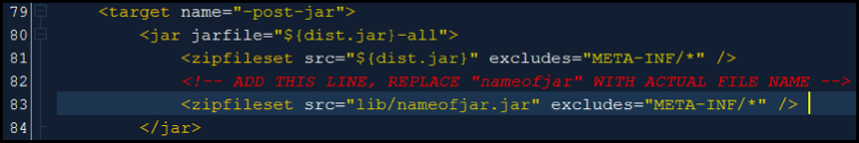

Troubleshooting
If you have any trouble developing a plugin, the Savant Development Team would be happy to help via email to savant [at] cs [dot] toronto [dot] edu.

Copyright © 2011. All rights reserved.

The format of the plugin.xml file is borrowed from the Java Plugin Framework. Much of the file is no longer relevant to Savant’s plugin framework, and can safely be ignored.

